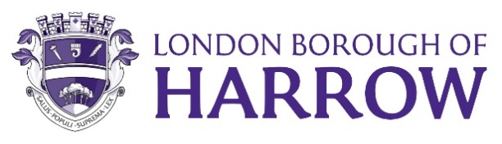

Cabinet – 27 July 2023

Reference from Governance, Audit, Risk Management and Standards (GARMS) Committee 5thJuly 2023

76. Treasury Management Annual Outturn Report 2022/2023

RESOLVED: That

- the Committee notes the Treasury Management outturn position for 2022/23;

- the Committee refers the Treasury Management Annual Outturn Report 2022/23 to Cabinet for noting.

Reason for Decision:

- To promote effective financial management and comply with regulations issued under the Local Government Act 2003, the CIPFA Code of Practice on Treasury Management, and the CIPFA Prudential Code for Capital Finance, along with meeting the requirements of the Council’s Financial Regulations.

- To keep Members informed of Treasury Management activities and performance for 2022/23.

For information

Background Documents:
Agenda for Governance, Audit, Risk Management and Standards Committee on Wednesday 5 July 2023, 6.30 pm – London Borough of Harrow

Contact Officer:
Arun Birah Democratic and Electoral Services
Tel: 07928513442
Arun.Birah@harrow.gov.uk

